V RUSSIAN SYMPOSIUM
WITH INTERNATIONAL PARTICIPATION RUSNANOSAT-2023
(the completed registration form, together with the abstract of the report, must be sent to rusnanosat@mail.ru with the subject: RusNanoSat-2023-Author's surname in Latin letters (for example, RusNanoSat2023-Smith).

All fields are mandatory.
Surname
Name
Academic title
Academic degree
E-mail
Phone
Full name of the organization
(as on the organization’s website):
Abbreviated name of the organization
Position
Participation with or without report

Title of report in English
(Times New Roman 14 font, bold)

Full name¹, Full name²

¹Name of the organization of the first author
²Name of the organization of the second author

Author's contact e-mail specified in the registration form

Document margins 2.5 cm on each side. All text, except for the title of the report, is typed in Times New Roman 12; line spacing 1.5; indent of the first line of the paragraph 1.25; alignment of text to the width of the page without automatic hyphenation. The volume of the report materials is 3-5 pages.
To set formulas, you must use the built-in Microsoft Word formula editor (Microsoft Equation and MathType are not allowed).

Formula example:

$$x=\frac{-b±\sqrt{b^{2}-4ac}}{2a},$$ | (1)
$x$ is …

Figure example:

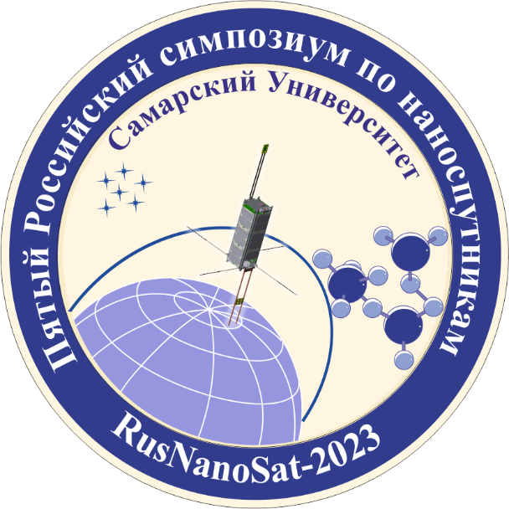
Figure 1 – Logo

Table design example:

Table 1 – Name of the table (if any)
Column 1 | Column 2 | Column 3
Examples of the design of bibliographic references:
- For the book:
McInnes C.R. Solar sailing: Technology, dynamics and mission applications. Springer Berlin, Heidelberg, 2004. 296 p.

- For the paper in a journal:
Vulpetti G., Santoli S., Mocci G. Preliminary investigation on carbon nanotube membranes for photon solar sails // Journal of the British Interplanetary Society. 2008. V. 61, Iss. 8. P. 284-289.

- For the proceedings of the conference:
Forward R.L. Grey solar sails // Proceedings of the 25th Joint Propulsion Conference (July, 10-12, 1989, Monterey, California).

